**ESTIMATION OF BUSINESS EXPENSES**

1. **Introduction:**

It showcases the distribution of expenses, identifies key cost drivers, and highlights areas of potential optimization or concern. The visual representations allow for intuitive analysis, facilitating a deeper understanding of expenditure patterns and their implications for business performance. Decision-makers, financial analysts, and stakeholders can gain valuable insights into the financial health of businesses, identify areas of inefficiency or opportunity, and make informed decisions to optimize resources and drive growth**.**

**2. Empathy Map:**

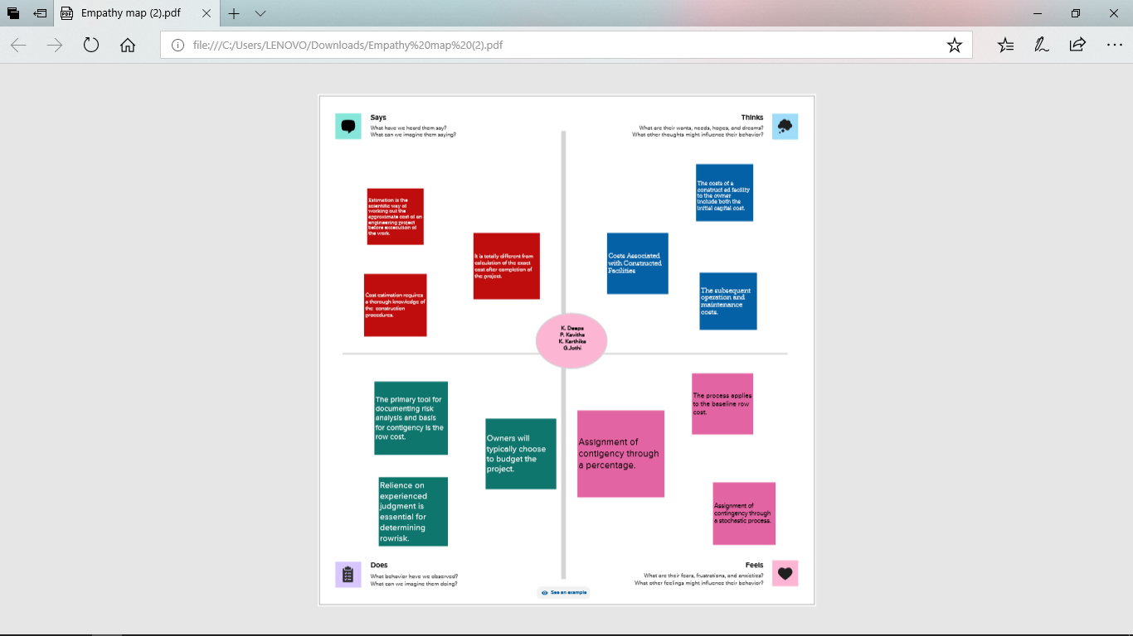

1. **Brainstroming Map & Ideation**

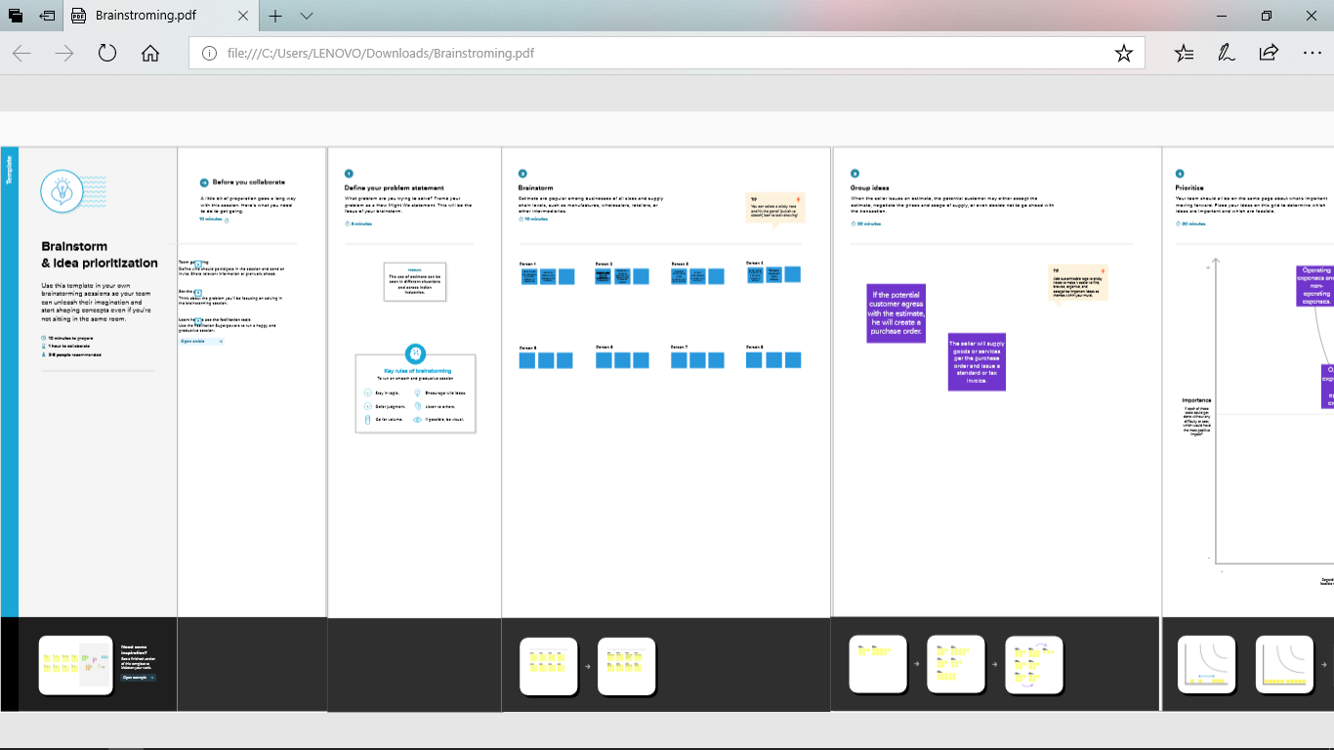

**4.Tableau Public**

**Annual Payroll**

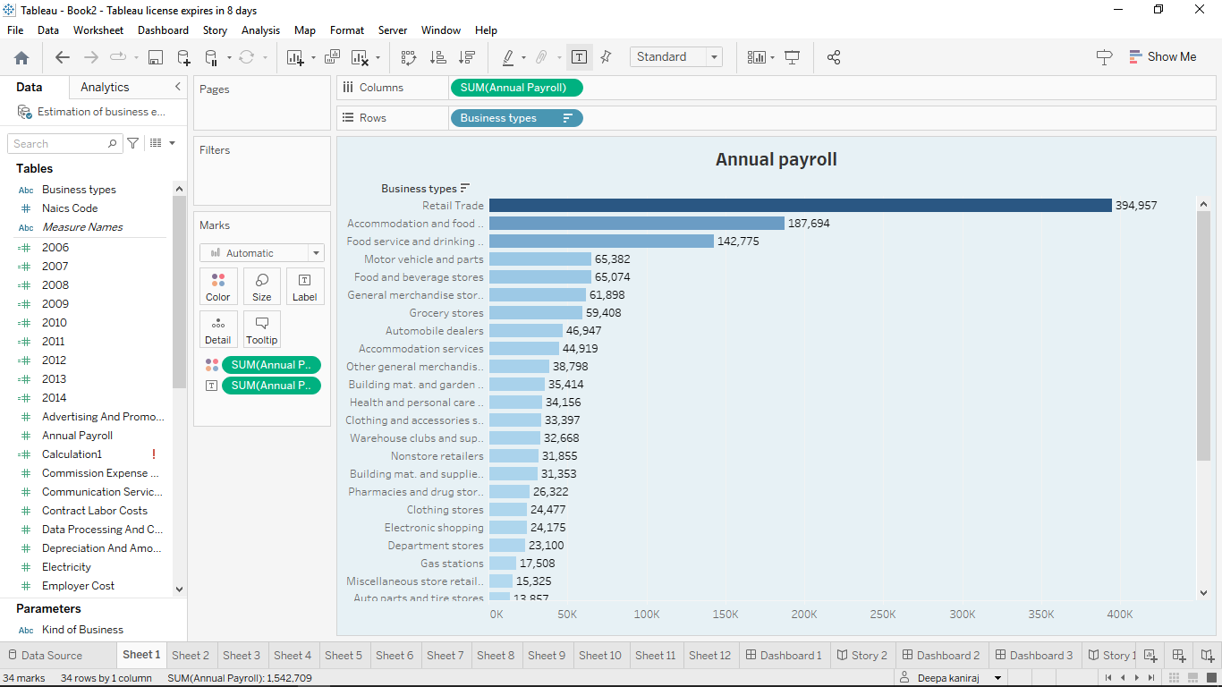

Advertisment cost

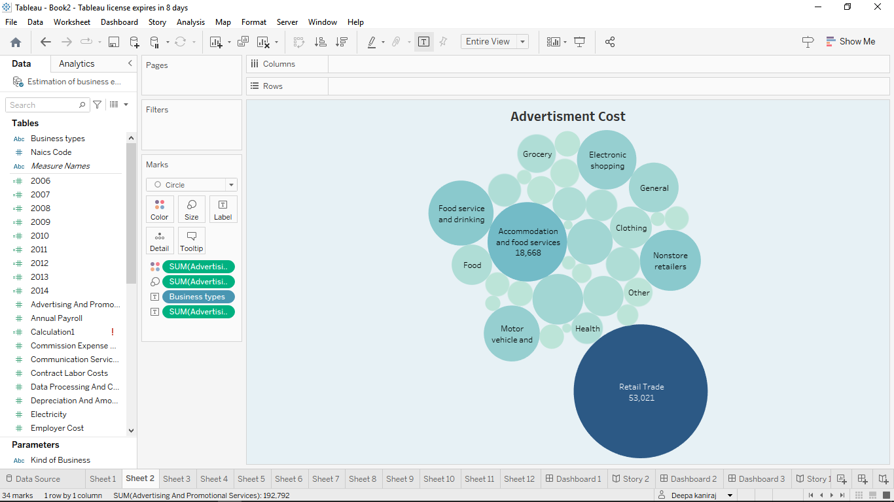

Contract Labour vs Employee

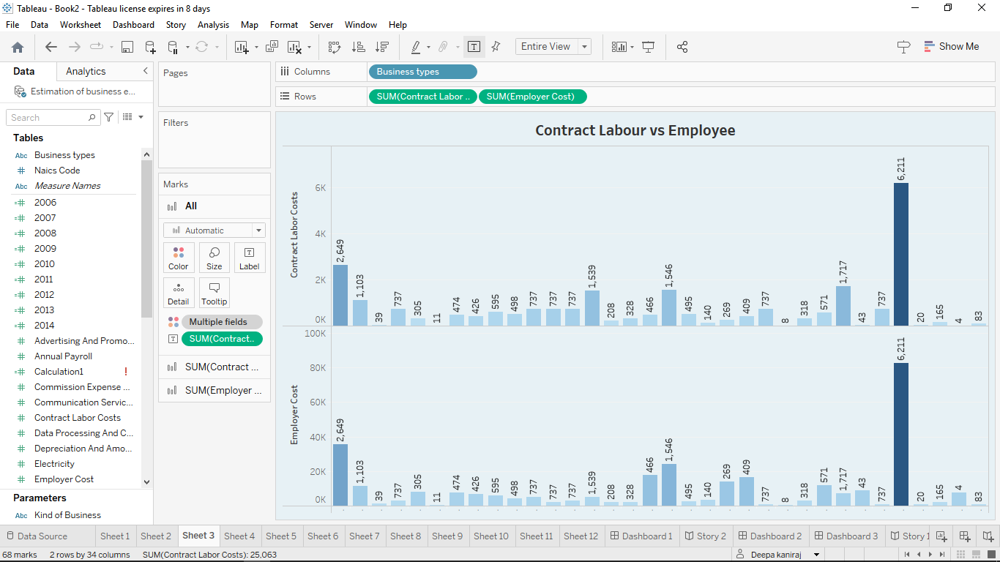

Employee (Insurance vs Pension)

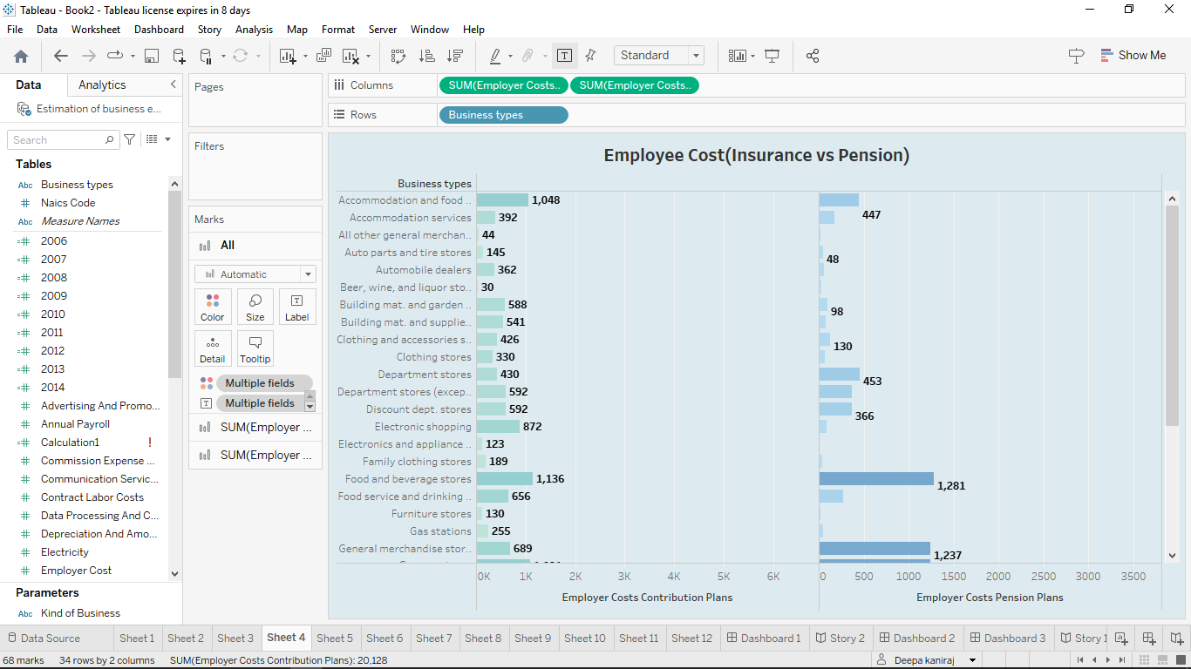

Equipment Costs

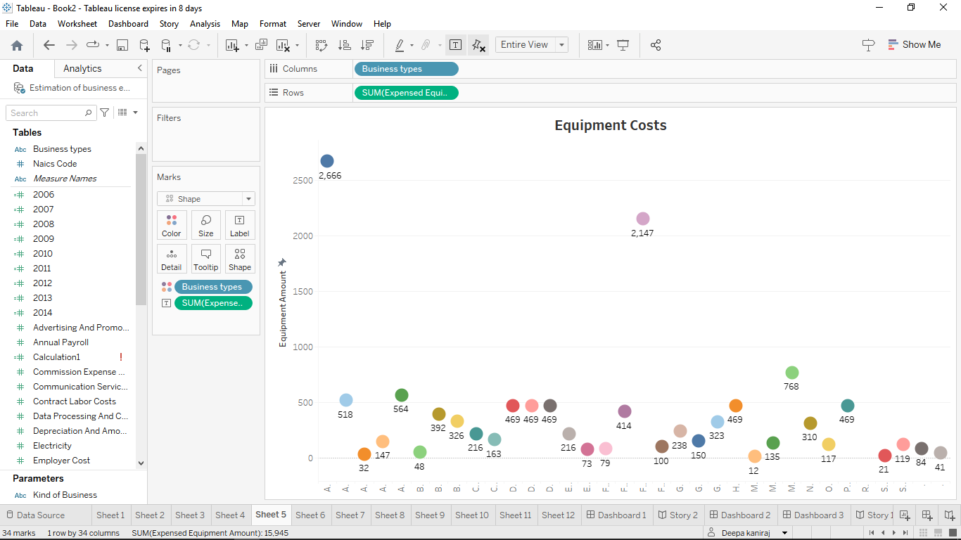

Expenses YoY

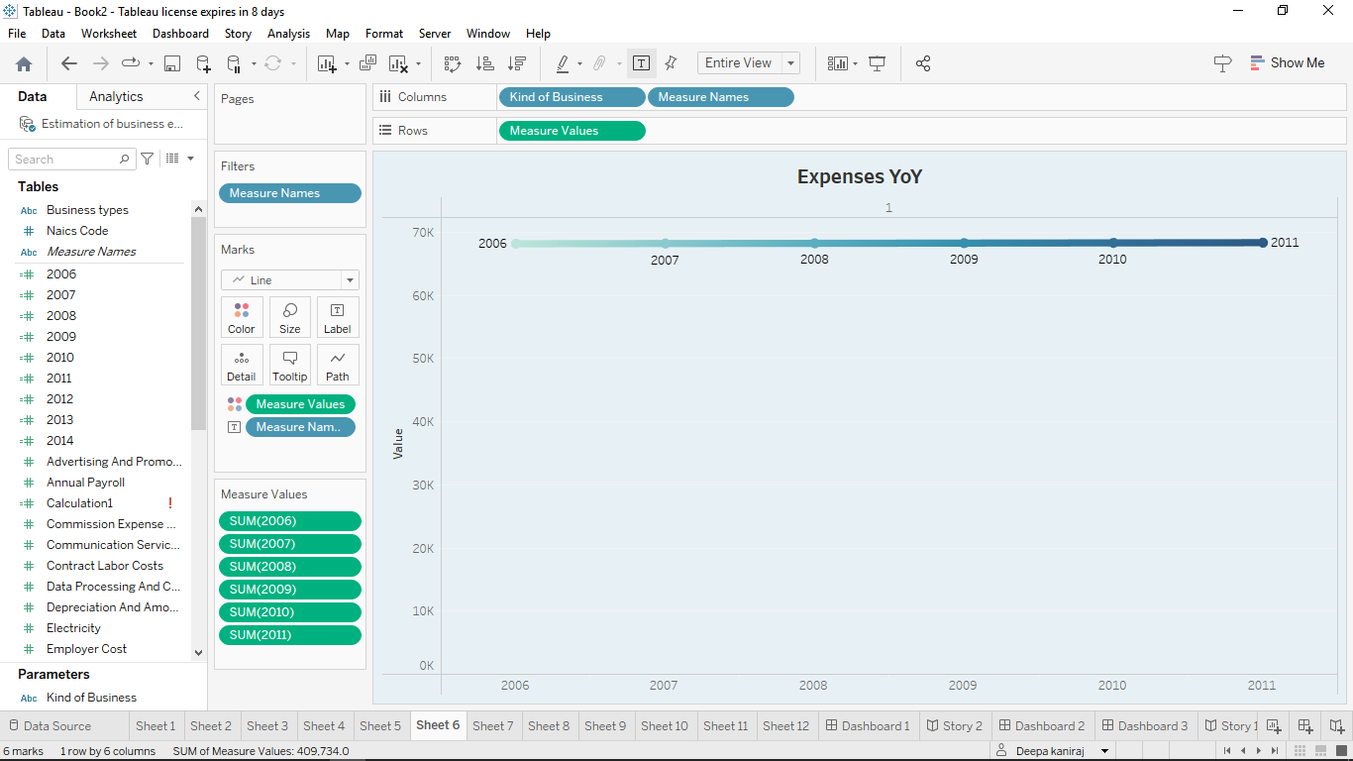

Fuel

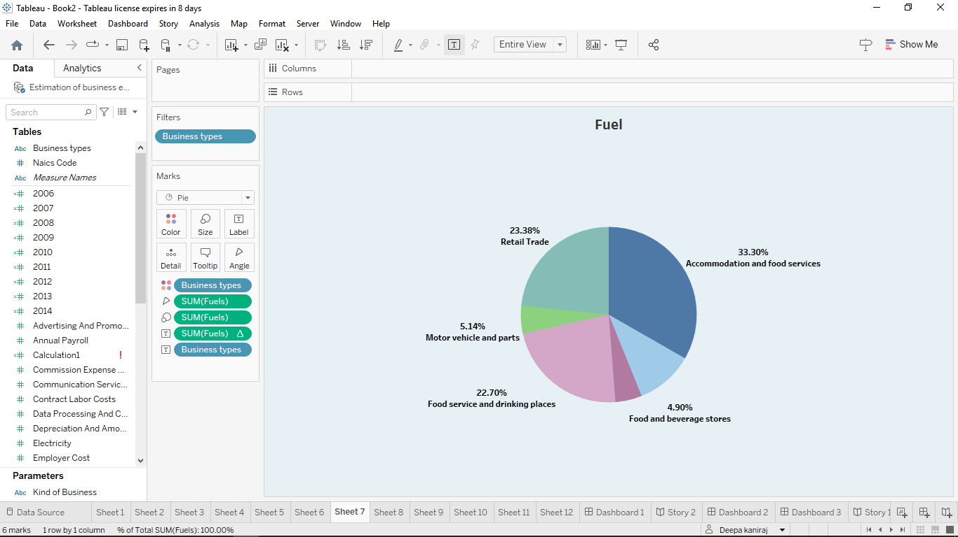

Maintenance Of Building

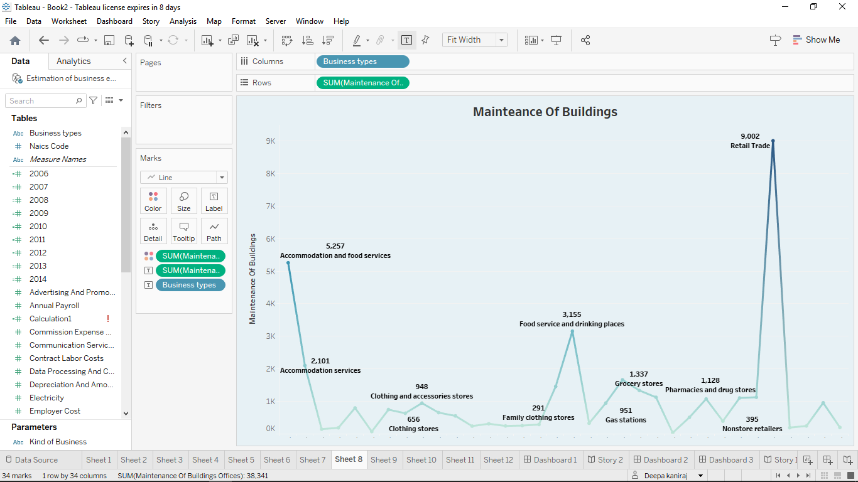

Power Expenditure

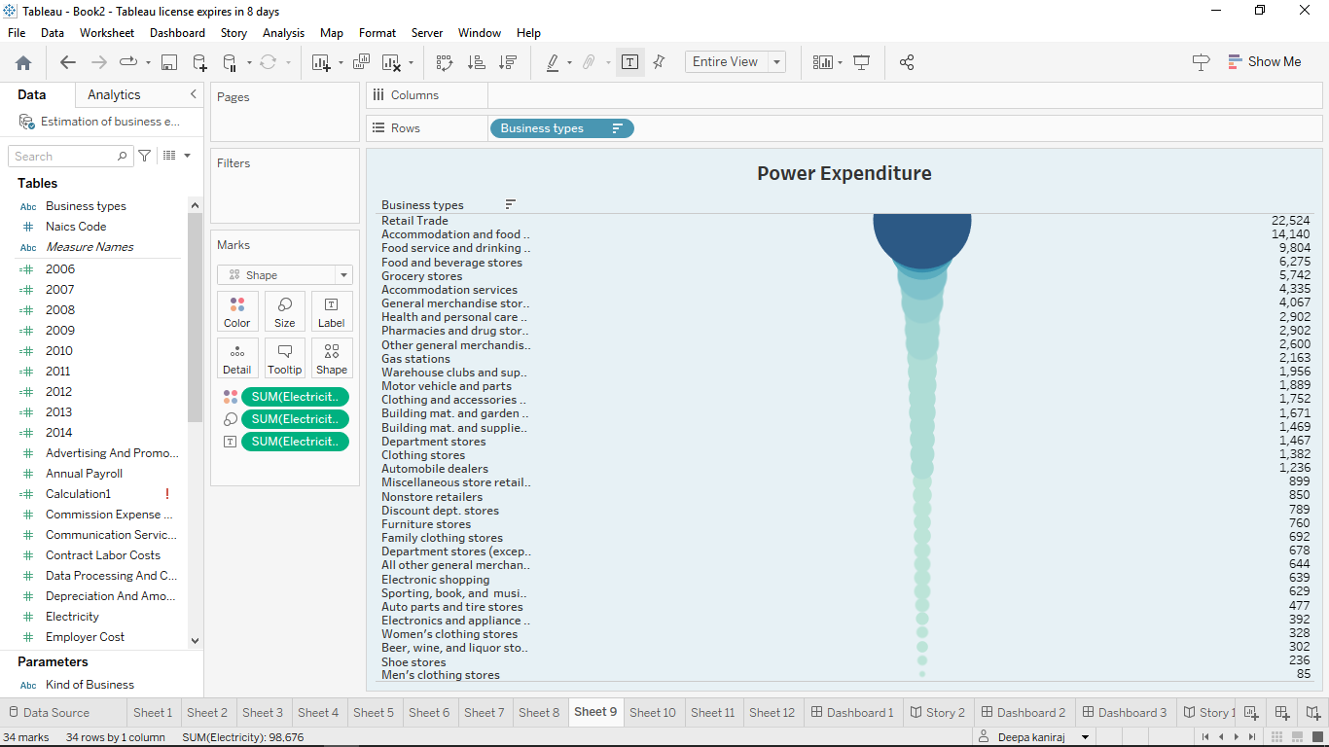

Rendal Payment Machinary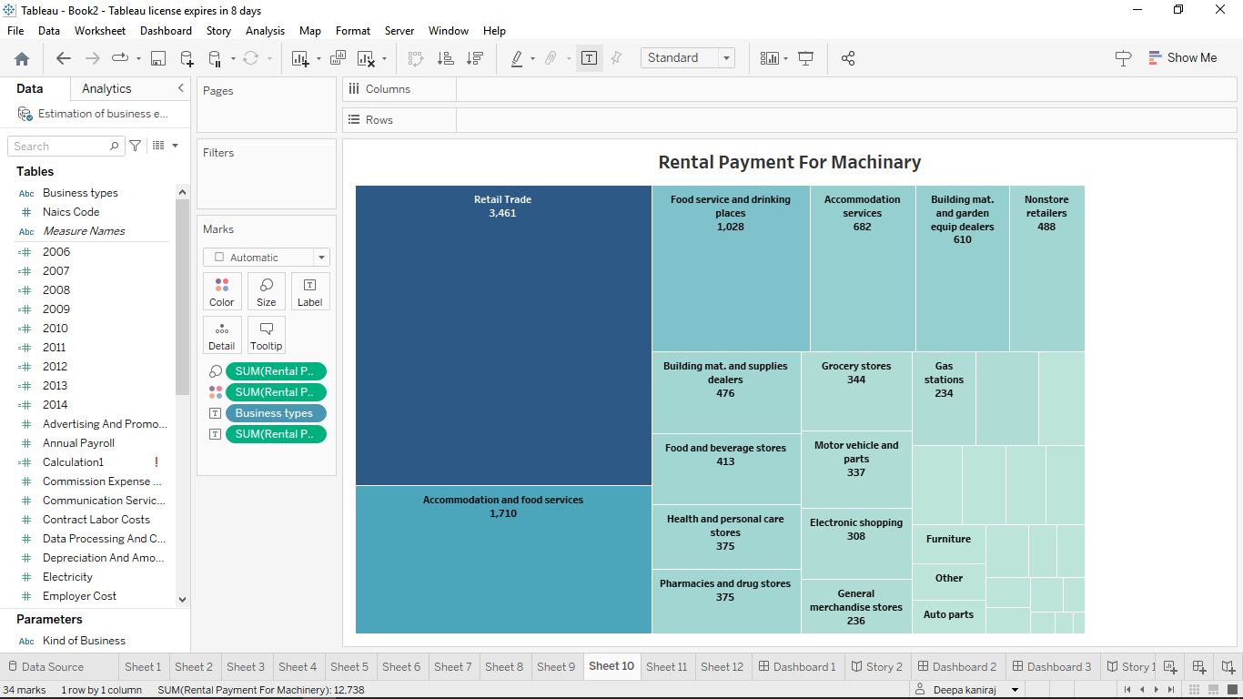

Taxes & License

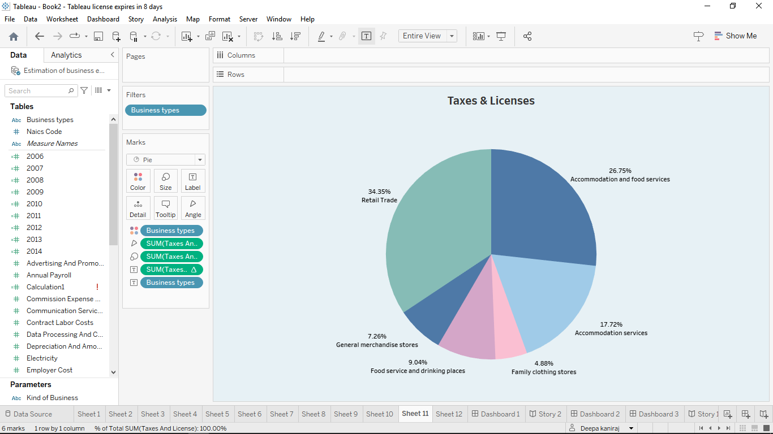

Transportation

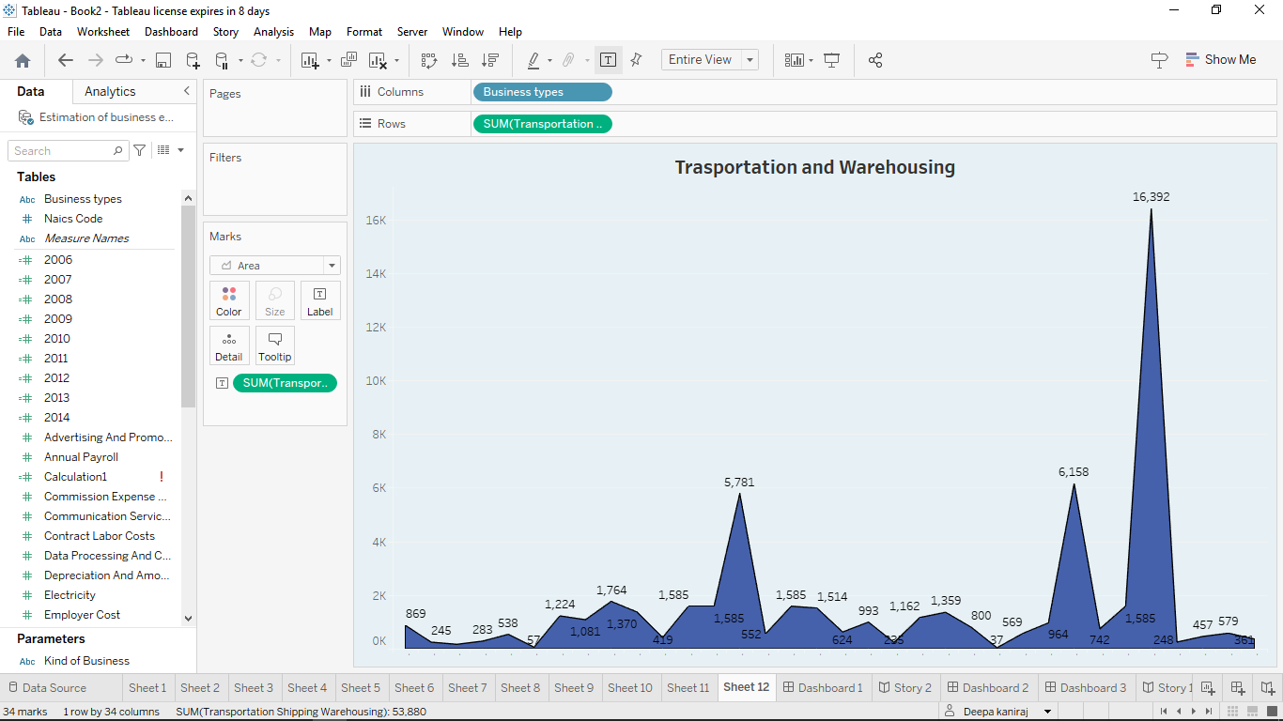

**4.Advandage and Disadvandages**

Social Impact: The analysis of business expenses and financial management has a significant social impact. It contributes to economic stability by optimizing costs and fostering long-term sustainability. Effective expense management creates job opportunities and supports the workforce. It allows for better resource allocation, enabling businesses to invest in innovation and community engagement. Responsible expense management aligns with societal expectations and promotes social responsibility.

Business Impact: Analysing business expenses has a profound impact on various aspects of business operations. It helps optimize costs, improve profitability, and ensure financial stability. Expense analysis enables businesses to allocate resources effectively, make informed decisions, and create realistic budgets and forecasts.

**5.Application:**

The primary business requirements for this report are to visualize and analyze business expenses, provide industry-specific insights, identify cost drivers, highlight outliers, and offer interactive functionality. Stakeholders need a visual representation of expenses to compare and analyze spending patterns across different businesses and industries. The report should facilitate the identification of key cost drivers, enabling stakeholders to understand the primary factors contributing to expenses. Additionally, it should flag any outliers or anomalies for further investigation. **6. Conclution:**

One of the main goals of company management teams is to maximize profits. This is achieved by boosting revenues while keeping expenses in check. Slashing costs can help companies to make even more money from sales.

However, if expenses are cut too much it could also have a detrimental effect. For example, paying less on advertising reduces costs but also lowers the company’s visibility and ability to reach out to potential customers.

**7.Future scope**

[**https://public.tableau.com/views/story2_16971782600060/Story2?:language=en-GB&:display_cou**](https://public.tableau.com/views/story2_16971782600060/Story2?:language=en-GB&:display_cou)[**https://public.tableau.com/views/story1_16971782027170/Story1?:language=en-GB&:display_count=n&:origin=viz_share_linknt=n&:origin**](https://public.tableau.com/views/story1_16971782027170/Story1?:language=en-GB&:display_count=n&:origin=viz_share_linknt=n&:origin)[**https://public.tableau.com/views/Book2_16968444973880/Dashboard1?:language=en-GB&:display_count=n&:origin=viz_share_link=viz_share_link**](https://public.tableau.com/views/Book2_16968444973880/Dashboard1?:language=en-GB&:display_count=n&:origin=viz_share_link=viz_share_link)

https://public.tableau.com/views/Dashboard3_16971781063300/Dashboard3?:language=en-GB&:display_count=n&:origin=viz_share_link

https://public.tableau.com/views/Dashboard2_16971779971790/Dashboard2?:language=en-GB&:display_count=n&:origin=viz_share_link